Byzantine Fault Tolerance:

Agreement of what to do……..

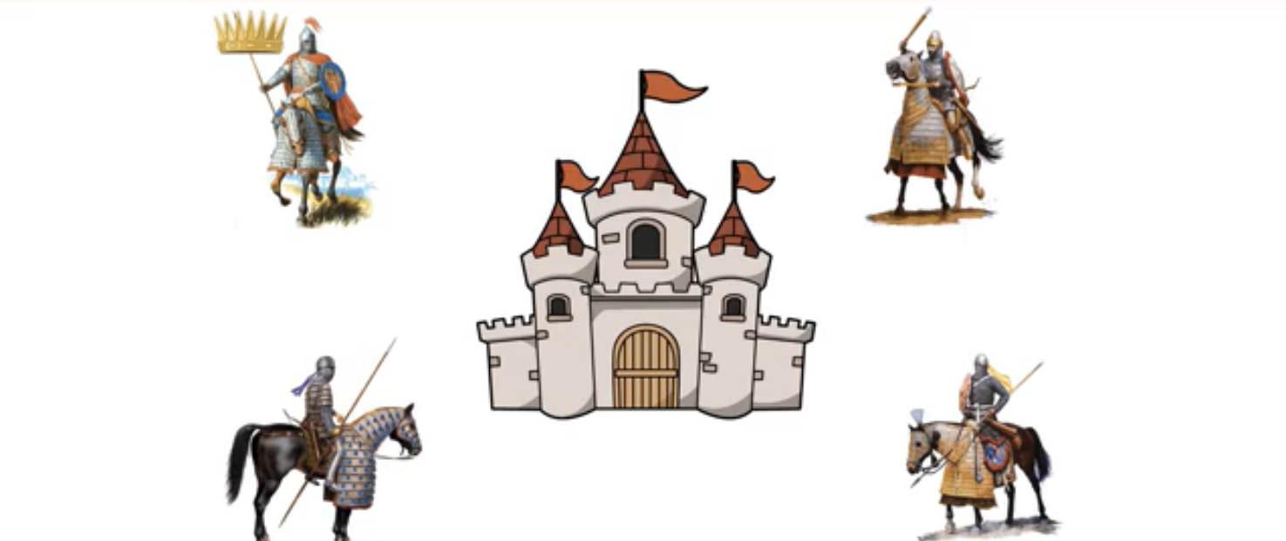

General 3

General 2

General 1

LEADER

attack

attack not attack